**What to see and do in May 2023**

**Sheringham Park, National Trust, Upper Sheringham, NR26 8TL**

Sheringham Park is a landscape park and woodland gardens with miles of stunning coastal views. The park was designed by the famous Humphry Repton in 1812. Spend a day here exploring the 1000 acres of varying habitat and see a vast collection of rhododendrons and azaleas, which are simply spectacular in May. Climb one of the many towers to experience breath-taking views open from dawn to dusk all year round.

**Holt Sunday Market 1st Sunday of the month** <https://loveholt.com/>

On market days Market Place and Star Plain is closed to vehicles for a day of Norfolk's independent best. With over 50 regional makers matched with 6 delicious street food traders, communal dining and buskers.

**Norfolk and Norwich Festival, 12 – 28 May** <https://nnfestival.org.uk/whats-on/>

For 17 days each May, the Festival transforms our public spaces, city streets, performance venues, parks, forests and beaches, bringing people together to experience the same brilliant and inspirational events. The flagship arts festival for the East of England, our world-class programme spans music, theatre, literature, visual arts, circus, dance and free outdoor events. The website has all the information about what is happening where and how to buy tickets. We are heading to see “Le Coup” circus in a quirky circus tent in the centre of chapelfield gardens in Norwich!

**14 May, Little Vintage Lovers Fair Mannington Estate, NR11 7BB**

<https://www.littlevintageloverfair.com/events>

There’s no better place to celebrate our love of vintage than at the gorgeous Mannington estate where they cannot wait to bring you our next event in the Spring, with over 40 stands of quality vintage to include an assortment of fashion, accessories, small homewares, curios, eclectic, handmade and much more. c 1920s-1980s. A great atmosphere with live DJ playing music to swing to while you wander the beautiful grounds and refreshments include organic and local street food vendors and Manningtons own tea room.

**Art by the Sea**

Art Trail around Happisburgh Village and Cart Cap, 27,28,29 May

<https://www.northnorfolkstudios.co.uk/art-by-the-sea-happisburgh-eccles>

**Bacton Village Art Exhibition, NR12 0ES, 27,28,29 May 10am til 5pm**

27,28,29 May, Bacton Village Hall, Paintings, prints and cards by the local art group.

**Great Yarmouth Races** <https://www.greatyarmouth-racecourse.co.uk/>

This historic racing venue is on the edge of Great Yarmouth, there are 2 fixtures of Spring Afternoon Flat racing this month on the 2 May and the 24 May

**Burnt Fen Alpacas, Horning, NR12 8AL, 01692 630553**

<https://burntfen.co.uk/walking-with-alpacas>

If you like the idea of something different, get in touch with Annie at Burnt Fenn, they offer visitors the chance to meet the herd of around 40 alpacas. With a variety of activities and experiences which include, walking with alpacas, alpaca yoga and alpaca cream teas. Contact them direct to find out more and to book your Alpaca experience.

**Ross’s River Trips 07791 526440**

Thesetrips are friendly and informal so you can relax and enjoy a trip into a landscape largely unchanged since medieval times. Lady Ann can carry up to 12 passengers, is stable, has an open-sided saloon and is perfect for viewing the unique wildlife in all weathers. The wildlife at Horsey includes rare resident birds such as marsh harriers, cranes, reedlings and bitterns. On fine days in late May and June the British swallowtail butterfly can be seen and on warm days the boat is frequently escorted by huge hawking dragonflies. The trips depart daily from Horsey Staithe, next to the NT windpump and can be booked in advance by contacting Ross

**Strumpshaw Steam Rally, NR12 4HR, 27,28,29 May,** <http://www.strumpshawsteammuseum.co.uk/events.html>

A traditional steam rally with steam engines, classic cars, working demonstrations, Shire horses and more, it a bit like stepping back in time!

**“The Yellow Book” National Open Garden Scheme 2023**  [www.ngs.org.uk](http://www.ngs.org.uk/) 7 May Kelling Hall, Kelling, Holt - 14 May Quaker Farm, Spixworth - 17 May Stody Lodge, Melton Constable 28 May Blickling Lodge, Aylsham - 21 May Bolwick Hall, Marsham

**Happisburgh Lighthouse open days & May & 28 May, 10 – 5.**

It is great to be able to see inside this iconic building and the views of coast and countryside are fabulous. Prebooking advised but not essential.

<http://happisburgh.org.uk/lighthouse/open-days/>

**Blickling Hall, National Trust, Blickling, Aylsham, NR11 6NF** It is only my opinion, but I think that Blickling is the best National Trust property in the area! It’s the combination of the stunning house, beautiful garden and large parkland. The Bluebells in the woods are outstanding. The second handbook shop is huge and was the first one in the trust and to top it off along with the Trust café there is a super pub called the Buckinghamshire Arms next door. <https://www.nationaltrust.org.uk/visit/norfolk/blickling-estate>

**Southern Comfort Paddle Boat River trips, Horning, NR12 8AA** The Southern Comfort is a double-deck paddle boat. A luxury river cruiser which runs regular trips from the beautiful village of Horning, along the River Bure through the village and out to Ranworth Broad and back, passing lovely old thatched houses, windmills and Norfolk reed beds. Throughout the trip there is an excellent commentary and continual pointing out of all the water birds around at the time.. For details on sailing times <http://www.southern-comfort.co.uk/>

**Horsey Seal Boat Trips**

Boats Trips from Sea Palling Beach, dates and times vary depending on the tide. Contact them on 07759331641 or 07968798700. There are a large number of adult seals on the beach at the moment and the boats are a great way to see them without disturbing them. They also offer Angling and Lobster trips

**21 May Asparagus Festival & Food Fair, 10am – 3pm, The Tacons Farm Shop, Rollesby** Local Food stands, Craft activities, cooking demonstrations and refreshments and of course lots of lovely farm grown asparagus

***Café of the month 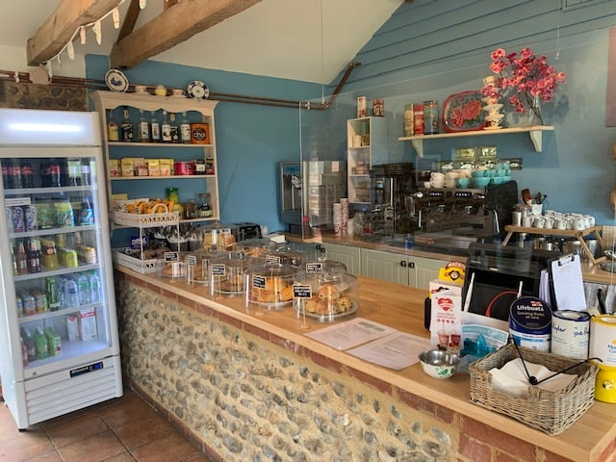 Small Sticks, Cart Gap Road, Happisburgh*** Named after the field surrounding the café, Smallsticks is just a short stroll from the beach and has an lovely garden where you can enjoy views across the farmland to Happisburgh lighthouse, sourcing as much of the menu as possible locally - including crabs straight from the boat at Cart Gap and eggs and potatoes from the farm. We loved the cake and the friendly staff; it was the perfect place to stop after a walk on the beach. Opening times: 10 – 3.30pm Fri, Sat, Sun, Mon